Chicago Periclean January 2015
Good Afternoon and Happy New Year!

We have a lot of really great things planned to make this the most successful year for the Sons of Pericles! We have Chapter, District, and National events that will be sure to have our members excited! We would like to update you on the events that have taken place during December and the beginning of January with more events to come. Stay tuned for an updated calendar as well as events that will take place in the coming months!

News:

Ypsilanti 22 Prepares for Greeks in LA
January 1st, 2015
The Sons of Pericles Ypsilanti 22 chapter of Chicago is excited to attend the Greeks in LA Basketball Tournament during Martin Luther King Weekend. The team will compete in a seven team tournament against Sons teams from across the country. eight members will be representing Ypsilanti including Bobby Markatos, Nick Pappas, Louis Bakris, Peter Korbos, George Tselos, Peter Kostopolous, Richard Haritos, and Peter Thomas. Good Luck to our team! Besides the basketball tournment, the Sons has provided diverse opportunities to view the city including tours, nightlife, and a Greek night.

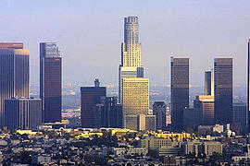

Ypsilanti Hosts a Successful Greek Night and Sticky Bloo Concert
January 10th, 2015
The Sons of Pericles Ypsilanti 22 chapter of Chicago hosted Sticky Bloo at Prime Time Restaurant for their second stint at the venue. Sticky Bloo comprises of Sons and Ahepa members of the Indiana chapters. They played to a capacity crowd of over 400 Greek Americans. It proved to be a very successful evening for the band. Following the performance, Louis Bakris provided Greek Night at Prime Time. Everyone was able to Greek dance for the remainder of the night. A big thanks goes out to Sticky Bloo, Louis Bakris, Nick Pappas, Bobby Markatos,and Prime Time for helping to put on such an amazing event.
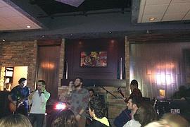

Ypsilanti has First Annual Ski Trip
January 2nd and 3rd, 2015
The Sons of Pericles Ypsilanti 22 chapter of Chicago had their first annual ski trip in Lake Geneva Wisconsin. Eleven members attended the trip that began early on January 2nd. The group was able to ski the slopes during the afternoon and spent the night near the Grand Geneva Resort. A big thank you goes out to Zach Chiganos who was the chairman of this event as well as to Chapter President of Ypsilanti 22 Nick Pappas and Indiana University Chapter President Louis Bakris for helping to make sure that our members were taken care of. We look forward to this event next year!
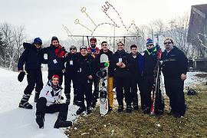

Ypsilanti Helps Out to Rebuild Saint Nicholas at Ground Zero New York
December 31st, 2014
The Sons of Pericles Ypsilanti 22 chapter of Chicago was able to raise $500 to help with the efforts to rebuild Saint Nicholas Church at Ground Zero. This church was destoryed when the twin towers fell on 9/11. Our organization nationally has agreed to help fund the rebuilding of Saint Nicholas as our National Project for the next two years. Our first task was to sell high roller raffle tickets. Ypsilanti had 5 tickets at $100 each. Together, the chapter was able to raise the $500 needed to hit our tarket. Nationally, the Sons of pericles were able to donate $7,000 to this great project! The winner was announed at the Boston Sons of Pericles annual New Year's Eve Party. We still have much more work to do but we are very excited about our accomplishments. Great job to our chapter
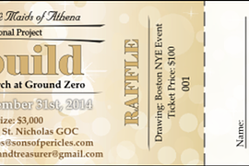

Ypsilanti Has Successful Christmas Party
December 20th, 2014
The Sons of Pericles Ypsilanti 22 chapter of Chicago had a successful Christmas get together at Prime Time Restaurant in Hickory Hills Illinois. It was great way to start winter break for our group! We have also already brought in 20 bags of clothes to donate to people in need! Our drive will conclude on January 30th. Thank you all for a great year in 2014! 2015 is going to be even better!

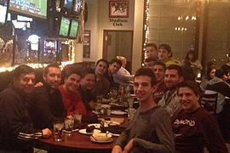

Sons of Pericles Ypsilanti Chapter 22
South Side Chicago IL
www.sop22.com
10309 S Roberts Road Palos Hills IL
219-5-SONS-YP
(219)576-6797
sopchi22@aol.com

